**Week 2 Module 3.2 Assignment CHO HAN Flowchart**

Juan Macias Vasquez

Bellevue University

CSD325-H323 Advanced Python (2255-DD)

**Jack Lusby**

June 8th, 2025

Module 3.2 Assignment CHO HAN Flowchart

Module 3 – Cho-Han Flowchart

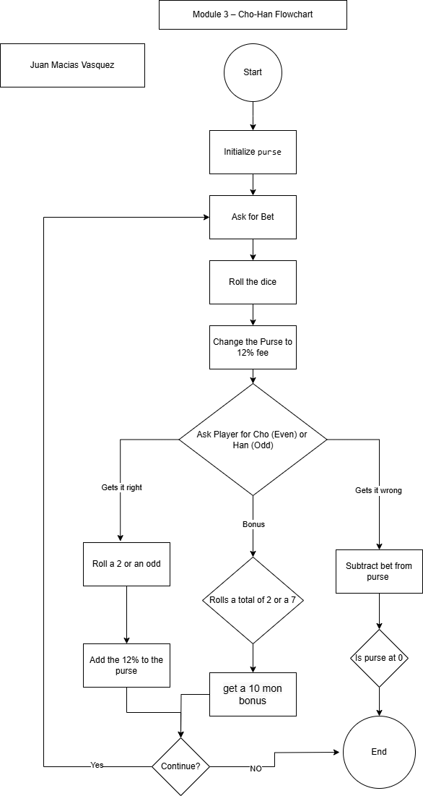

Made in Draw.io